Steps / Navigation | SYSTEM SCREENSHOTS | COMMENTS / REMARKS
Click on Menu option:  Annual General Meeting > Filter the AGM Workflow >  Action – Select AGM Workflow (Dentons) | 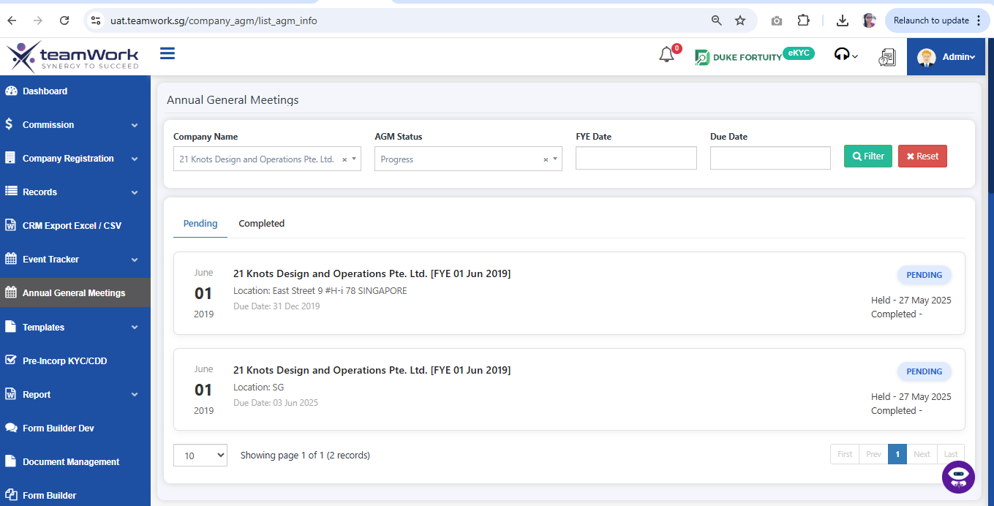
Choose Audit status  Click on:  AGM Workflow -> Select Exempt audit or non- exempt audit based on requirement | 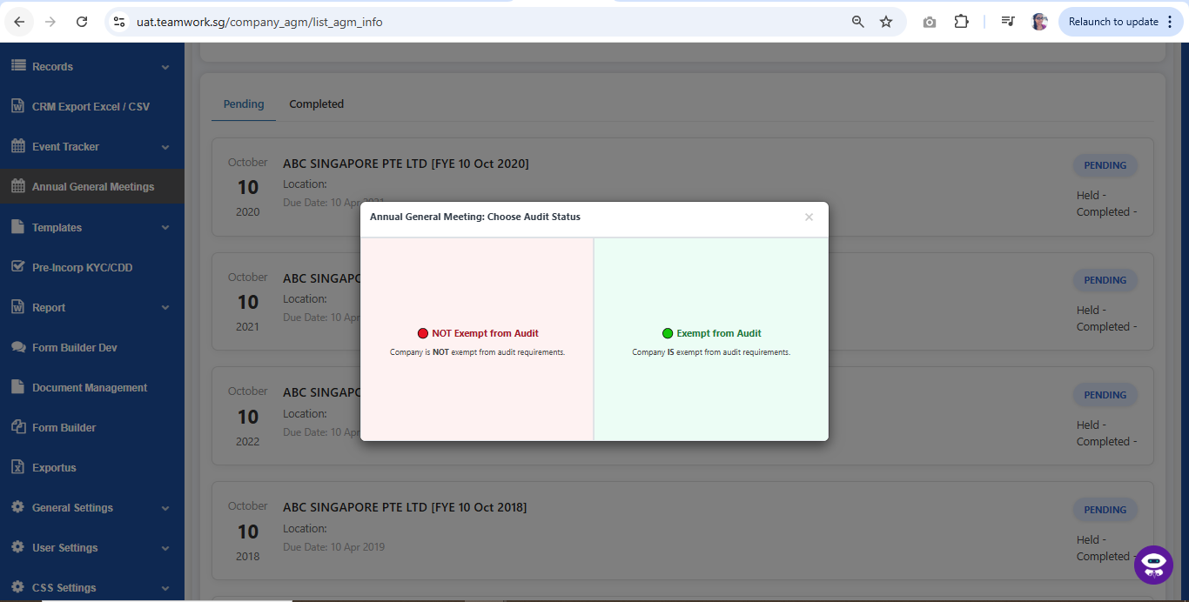
Overview Page  Click on:  Overview  This option Shows AGM overview Datas of the company. | 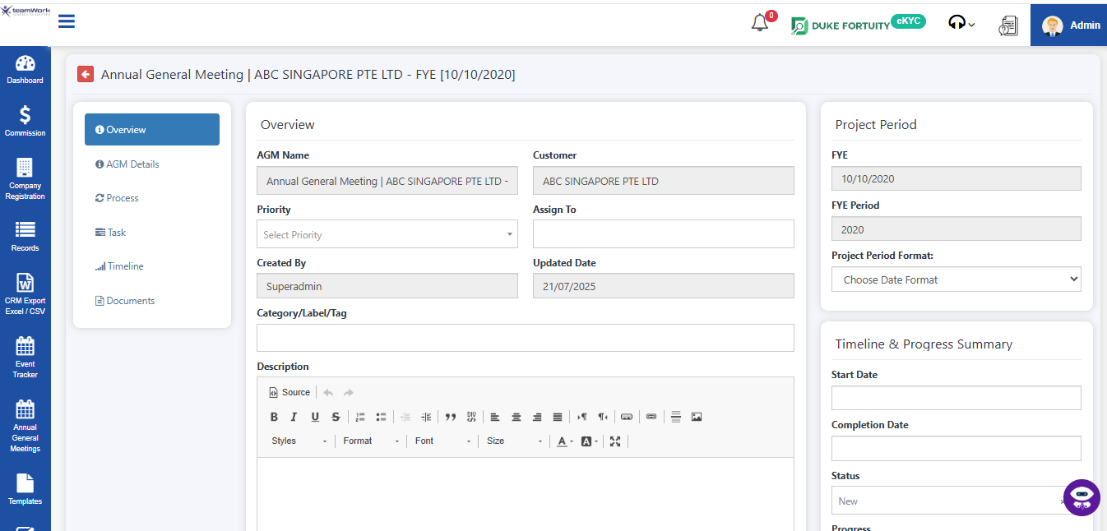
AGM Details  Check on the AGM Details to know about Basic and Status Information  Click on:  + Edit AGM to add anything about AGM | 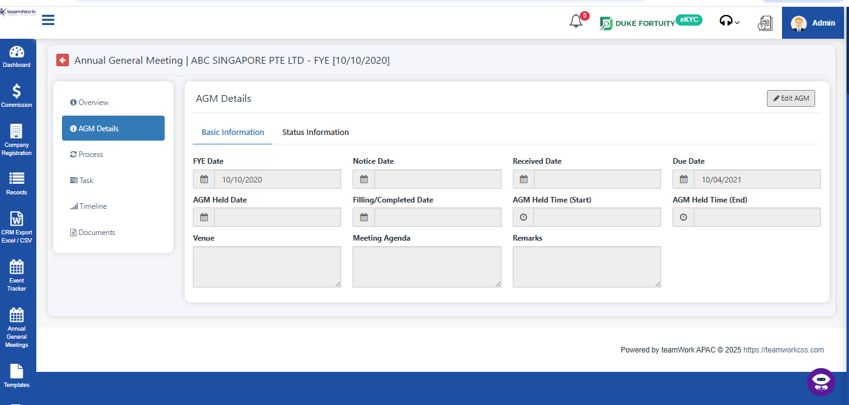
Process  System will show the Allocated Process(s) & Unallocated Process(s) based on exempt and non-exempt from audit requirements  Click on:  + 1. Click on Confirm Allocation to Allocate processes | 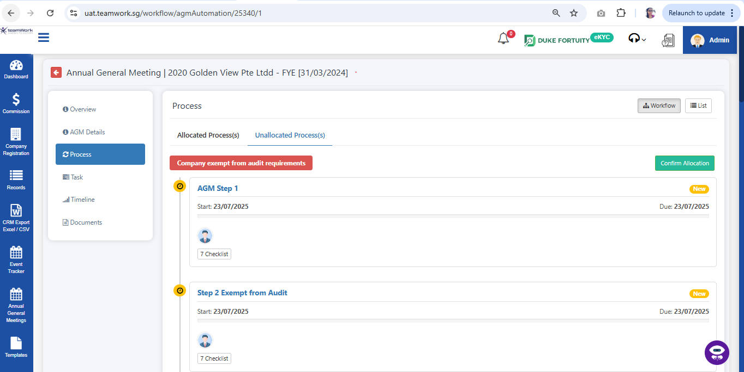
AGM Step 1  System will show the AGM Step 1  Click on:  + 1. Edit | 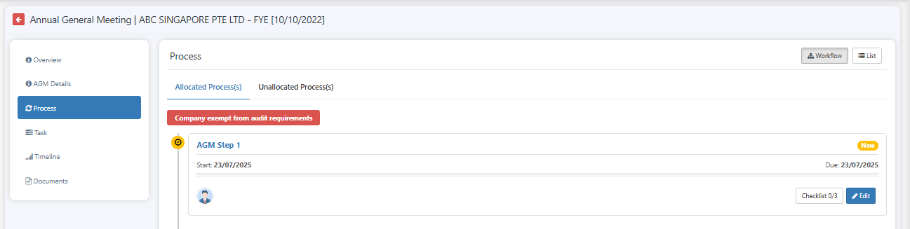
Checklist  System will show the AGM Checklist  - In Checklist , can edit , mark tick , untick , add and delete  - Auditor workflow-> Can View all auditors, appoint and change or remove auditor | 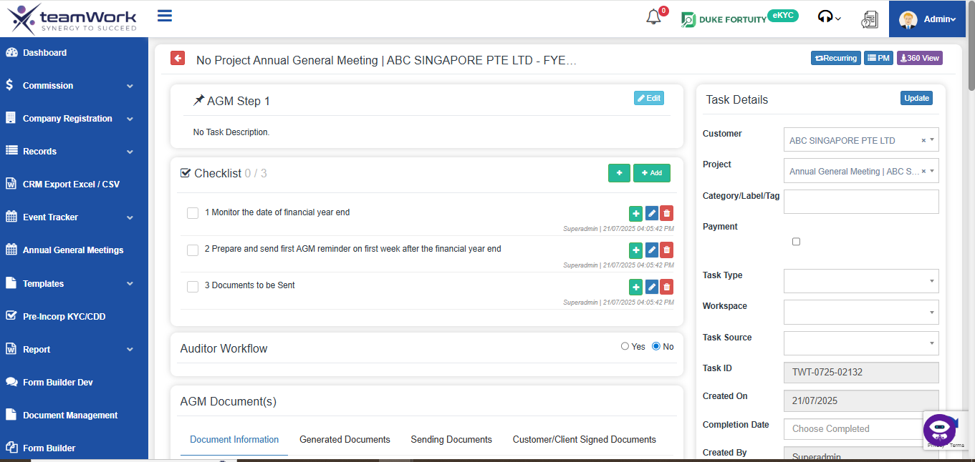
Auditor WorkFlow  System will show the Auditor WorkFlow by Yes or No option.  Yes shows Auditor worklows | 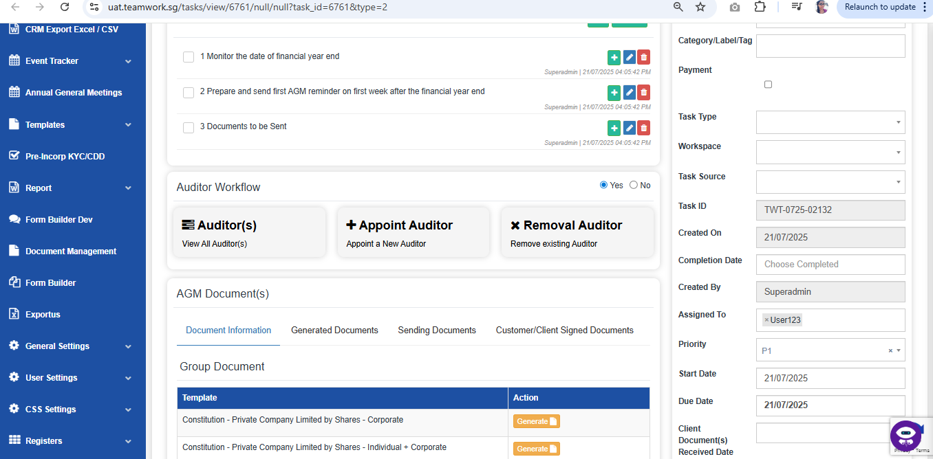
View all Auditors  - Click Auditors -> View all Auditors by navigating to Auditor pages  There can check all the auditor related data’s | 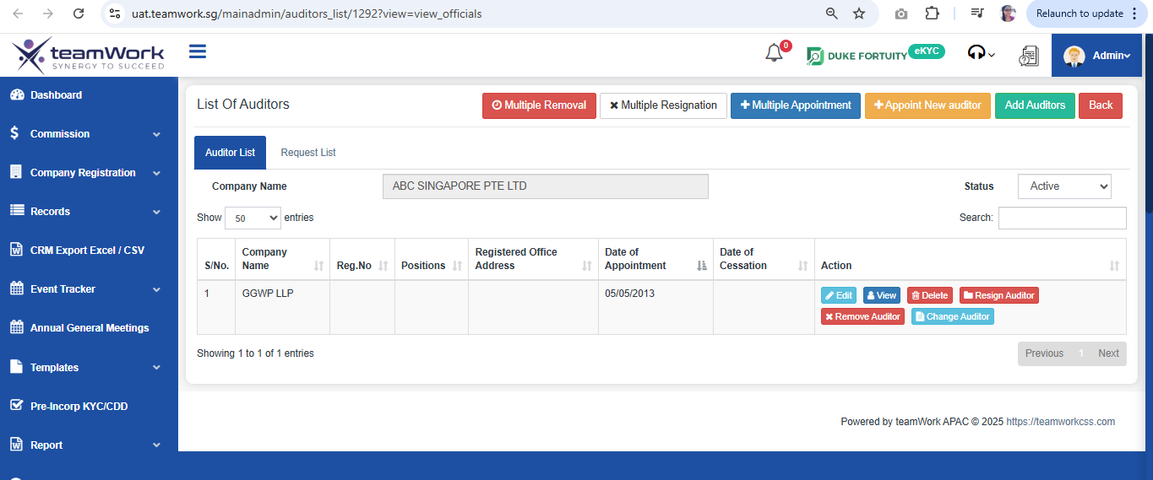
Appoint Auditors  - Click Appoint Auditors -> It navigating to Appoint Auditor page  - There can Add new auditor by filling the forms | 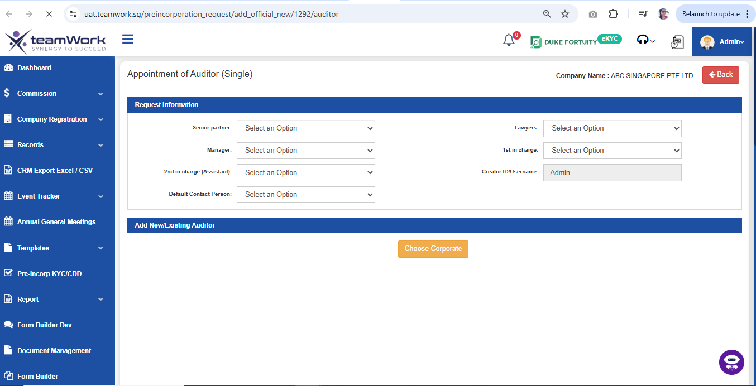
Removal Auditors  - Click Remove or Change Auditors -> It navigating to Remove or Change Auditor page  - There can Remove or change auditor by filling the forms or can select in the list shown below | 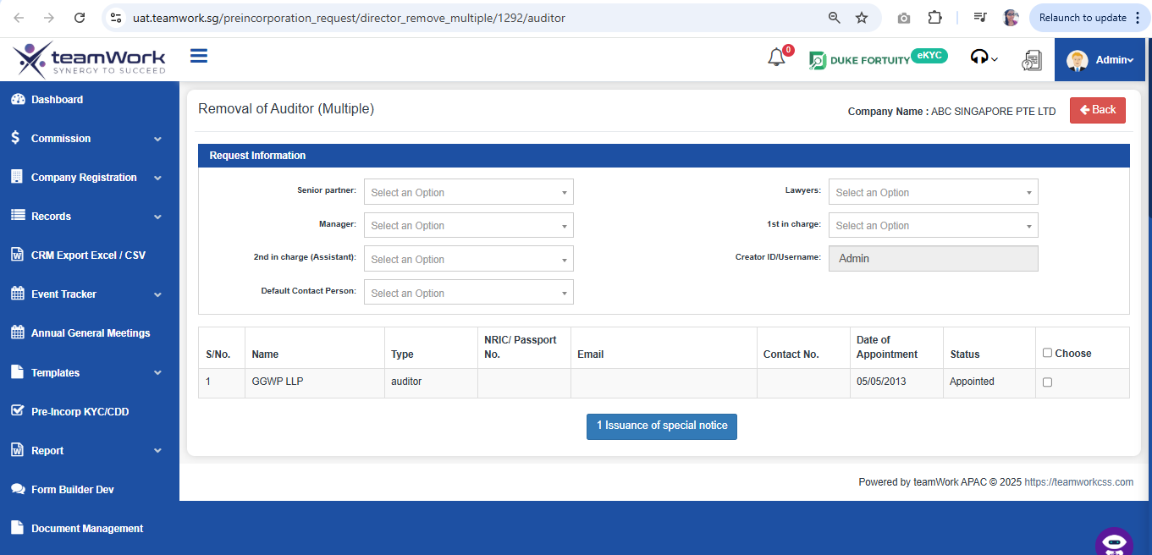
AGM Documents  - Document Information -> Can check Group Document and Template Document. Also can generate the document. | 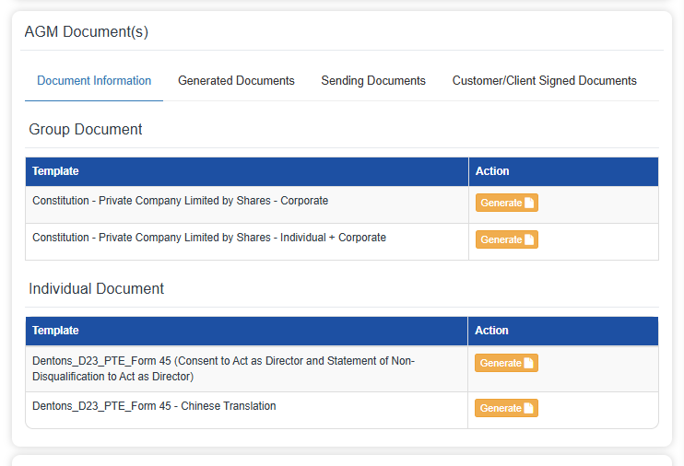
- Generated Documents -> Can check all generated documents and can view, download or delete  Click on Generate @ Document Information Section to add templates into  Default Generated Documents Section  *Note that these templates are dummy templates.  Only the naming follows the given excel from Dentons  Generated Document @ Default Generated Documents Section can be previewed / deleted  Attach Custom Documents @ Add Custom Document Section  Click on + to attach more custom documents  Select Email Template (Pre-configured in Settings) to be sent out to Clients  Click on:  Submit & Email | 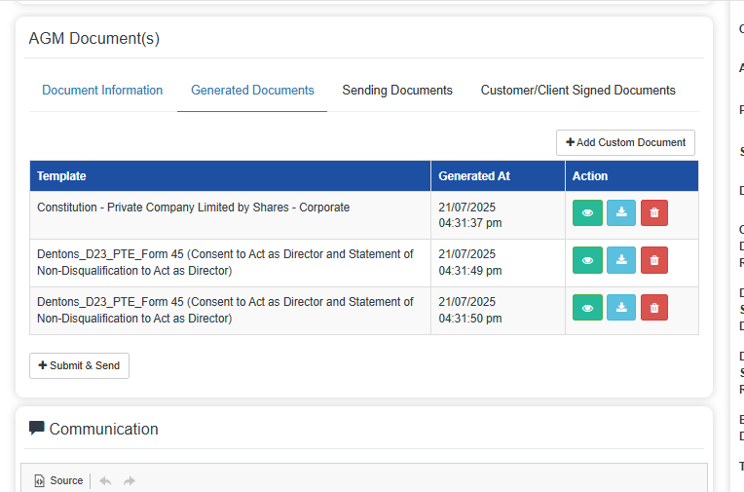  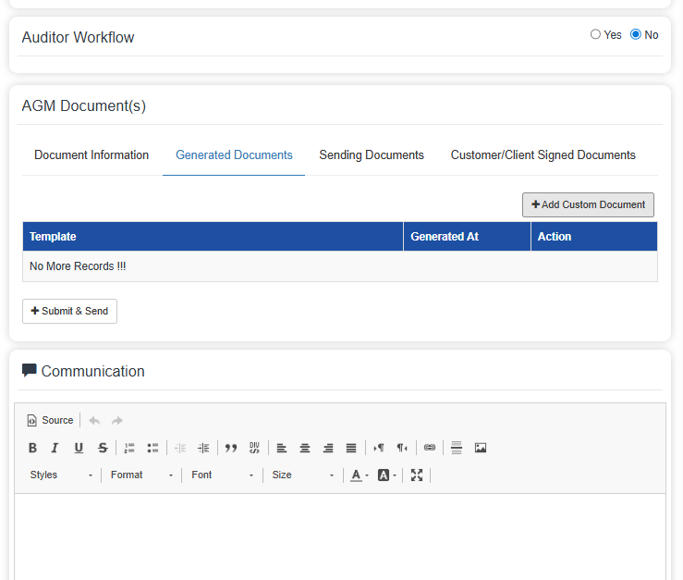
Email Preview from the defaulted chosen template with be displayed along with contact person email.  Email content can be amended at this stage before email is sent out to contact person  Click on:  - Send & Submit | 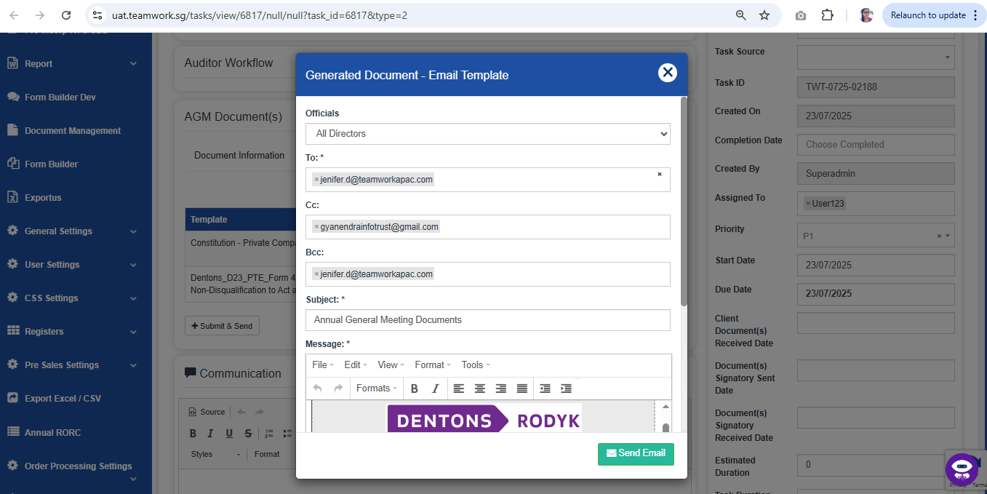
- Sending Documents -> Here can see all sending related data’s of the documents | 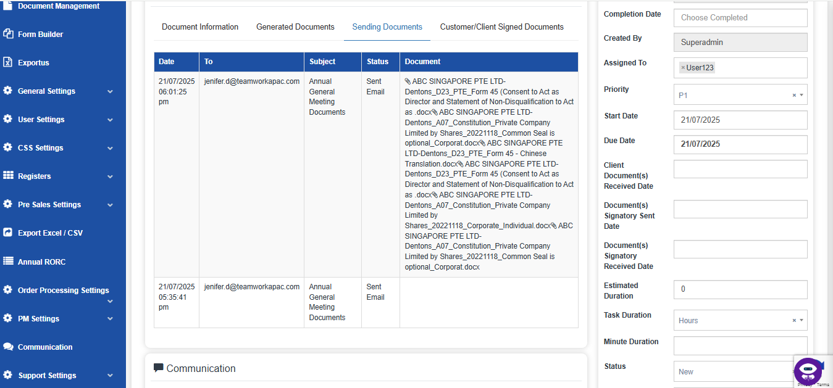
Denton’s Client Receive Email in their Inbox  Click on:  Update Document Link | 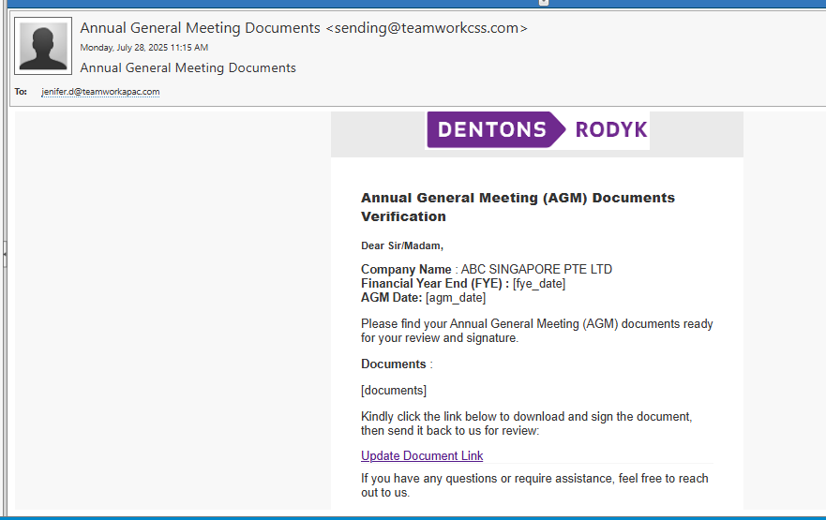
Denton’s Client Open URL  Official Download Documents Section:  Will display documents attached by Dentons:  - Generated Documents  - Custom Documents  Clients can upload the signed copies of the documents using the Upload section with the Upload Button  Your Uploaded Document Section:  Will display all the uploaded documents from client with Status: pending (just uploaded) | 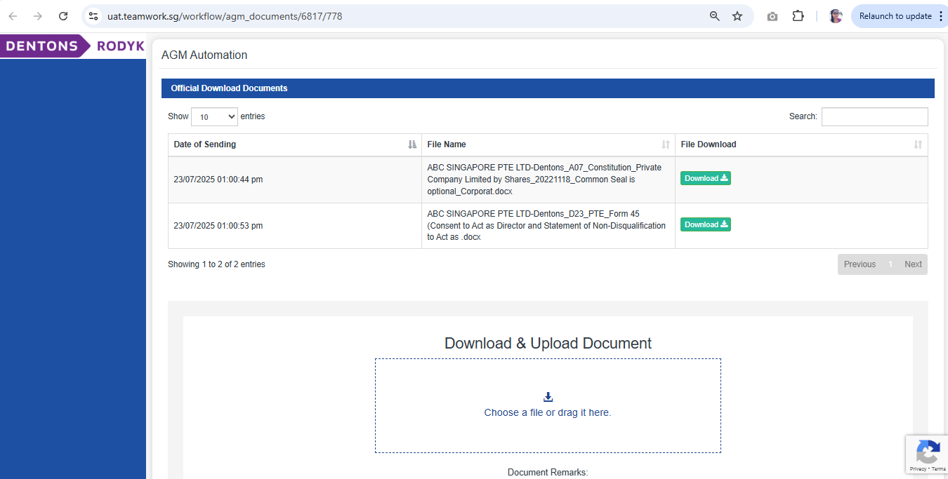  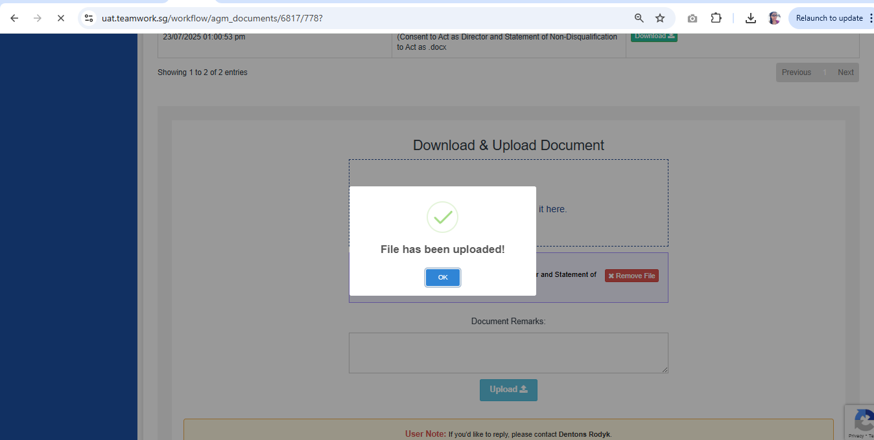
Your Uploaded Document Section:  Will display all the uploaded documents from client with Status: pending (just uploaded)  Click on:  Submit | 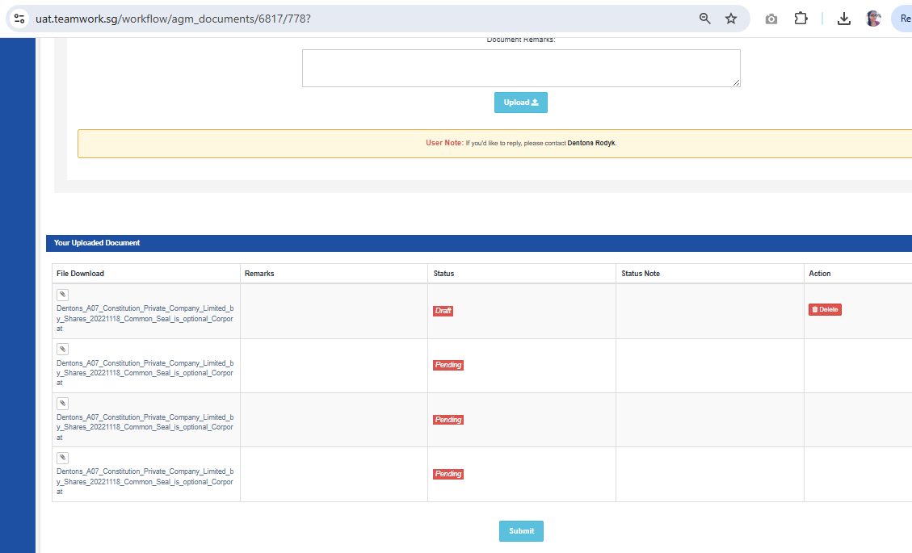
- Customer/Client Signed Documents -> Can check all generated documents and can view, download or delete | 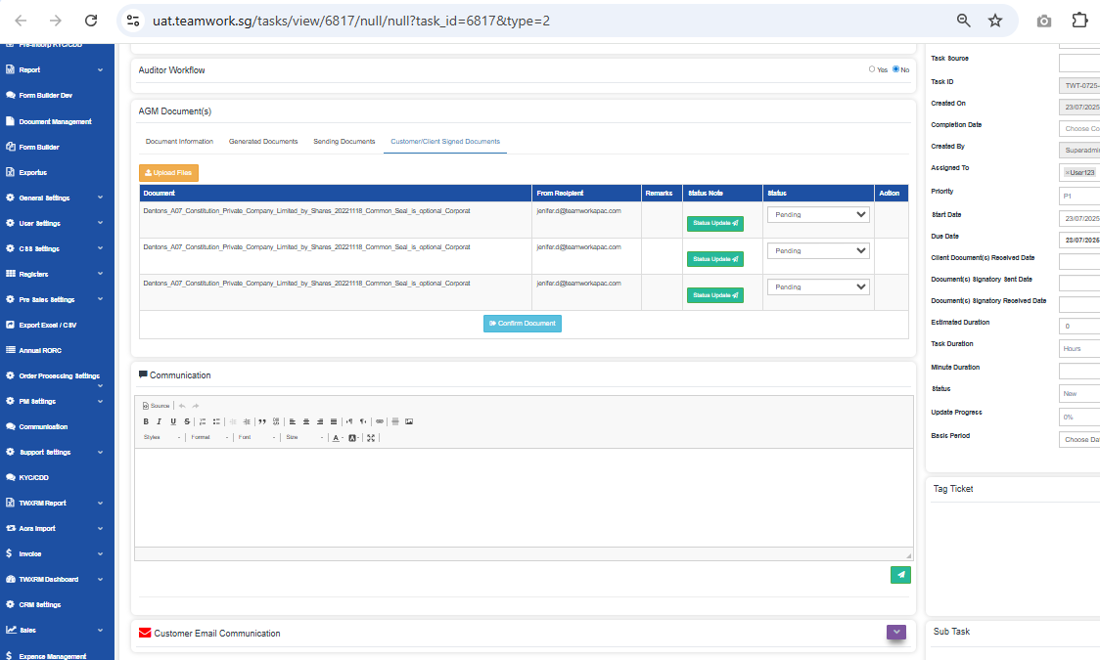
Confirm Document  After Changing the status of the document was completed, Pending, etc.  Submit Confirm Document -> Change the due Date.  It’s automatically return to Home page. | 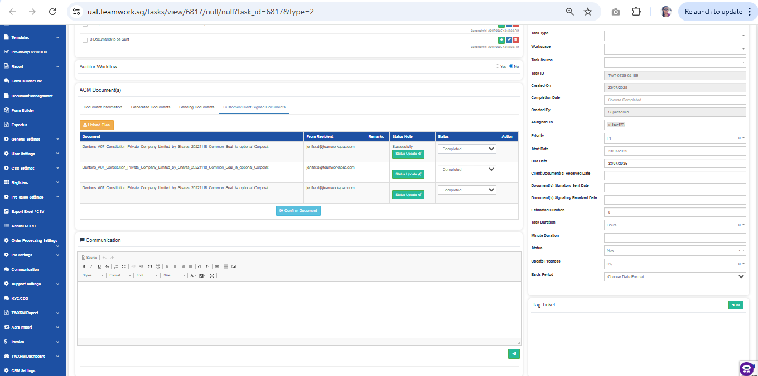
AGM Step 2  System will show the AGM Step 2  Click on:  + 1. Edit | 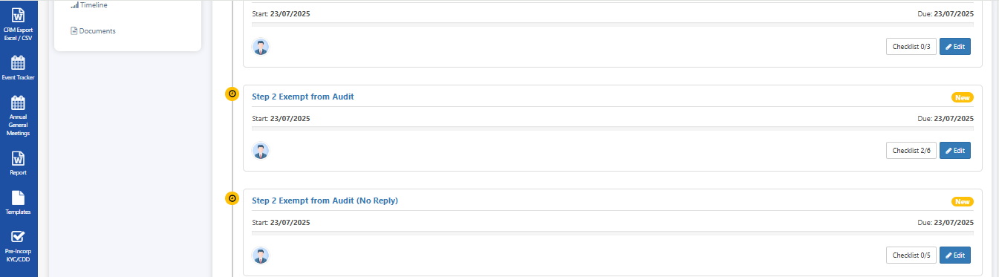
Checklist  Non-Exempt from Audit  System will show the AGM Checklist  - In Checklist , can edit , mark tick , untick , add and delete  - Auditor workflow-> Can View all auditors, appoint and change or remove auditor | 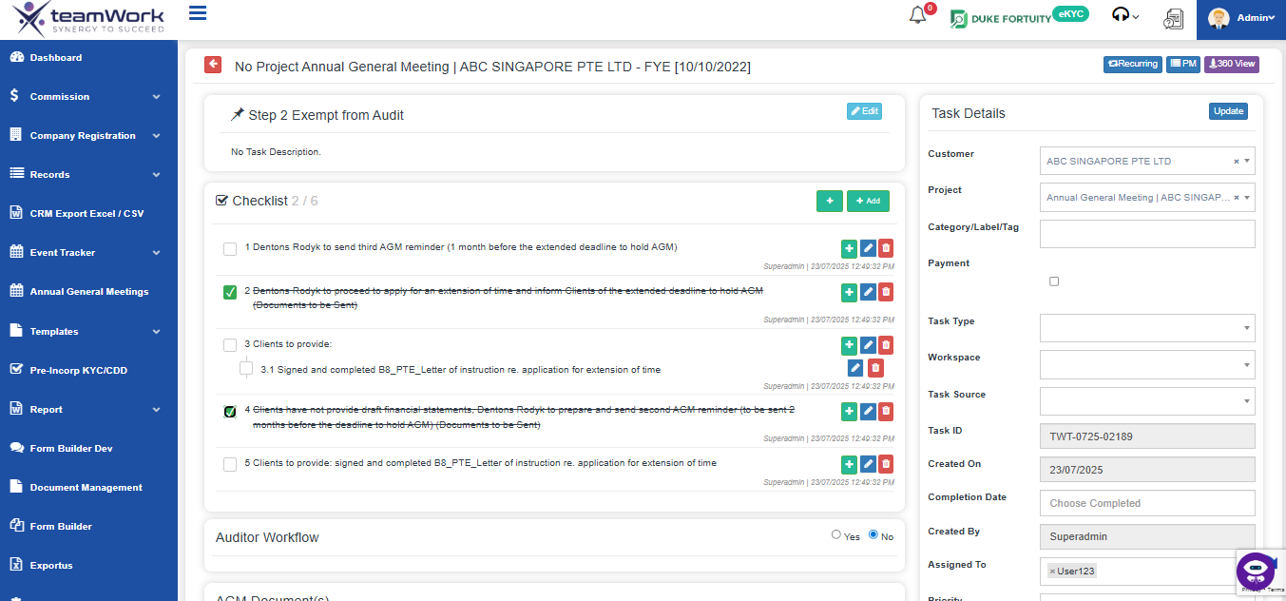
Auditor WorkFlow

System will show the Auditor WorkFlow by Yes or No option.
Yes shows Auditor worklows

View all Auditors
- Click Auditors -> View all Auditors by navigating to Auditor pages
There can check all the auditor related data’s

Appoint Auditors

- Click Appoint Auditors -> It navigating to Appoint Auditor page
- There can Add new auditor by filling the forms

Removal Auditors

- Click Remove or Change Auditors -> It navigating to Remove or Change Auditor page
- There can Remove or change auditor by filling the forms or can select in the list shown below

AGM Documents
- Document Information -> Can check Group Document and Template Document. Also can generate the document.

- Generated Documents -> Can check all generated documents and can view, download or delete

Click on Generate @ Document Information Section to add templates into
Default Generated Documents Section
*Note that these templates are dummy templates.
Only the naming follows the given excel from Dentons

Generated Document @ Default Generated Documents Section can be previewed / deleted
Attach Custom Documents @ Add Custom Document Section
Click on + to attach more custom documents

Select Email Template (Pre-configured in Settings) to be sent out to Clients

Click on:
Submit & Email
Email Preview from the defaulted chosen template with be displayed along with contact person email.

Email content can be amended at this stage before email is sent out to contact person

Click on:
- Send & Submit

- Sending Documents -> Here can see all sending related data’s of the documents

Denton’s Client Receive Email in their Inbox  Click on:  Update Document Link | 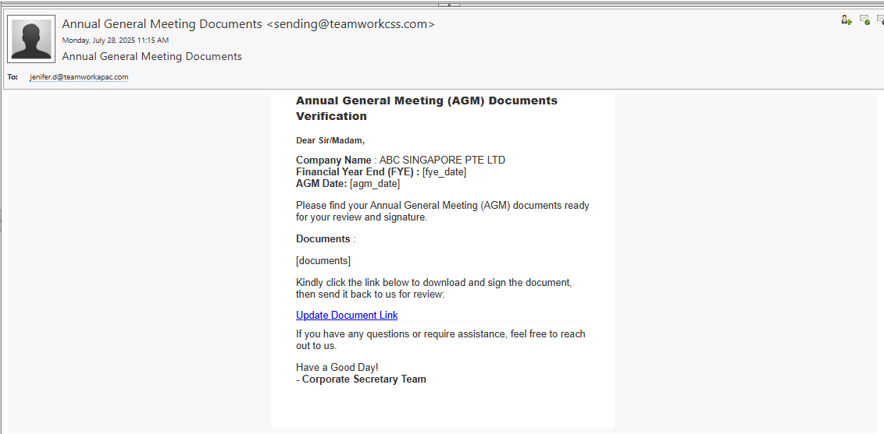
Denton’s Client Open URL

Official Download Documents Section:
Will display documents attached by Dentons:
- Generated Documents
- Custom Documents

Clients can upload the signed copies of the documents using the Upload section with the Upload Button

Your Uploaded Document Section:
Will display all the uploaded documents from client with Status: pending (just uploaded)
Your Uploaded Document Section:
Will display all the uploaded documents from client with Status: pending (just uploaded)

Click on:
Submit
- Customer/Client Signed Documents -> Can check all generated documents and can view, download or delete

Confirm Document
After Changing the status of the document was completed, Pending, etc.

Submit Confirm Document -> Change the due Date.
It’s automatically return to Home page.

Status Changed  After Return to Home page check the AGM steps Status. | 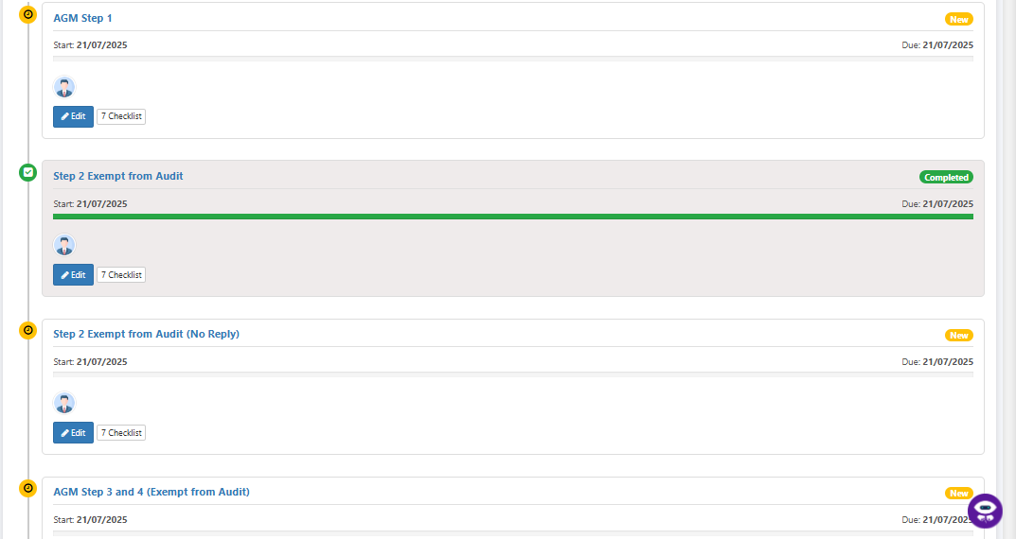
AGM Step 3 & 4  System will show the AGM Step 3 & 4  Click on:  + 1. Edit | 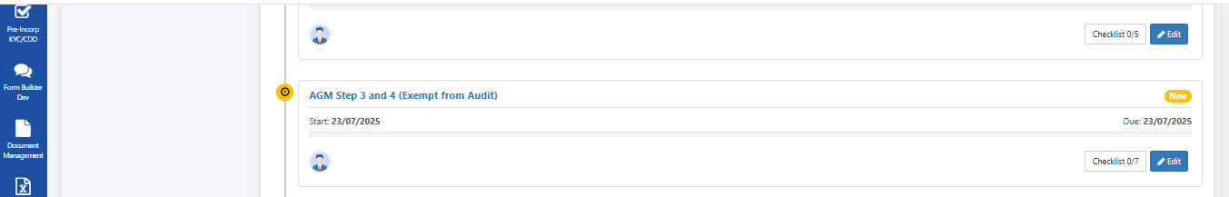
Checklist  Non-Exempt from Audit  System will show the AGM Checklist  - In Checklist , can edit , mark tick , untick , add and delete  - Auditor workflow-> Can View all auditors, appoint and change or remove auditor | 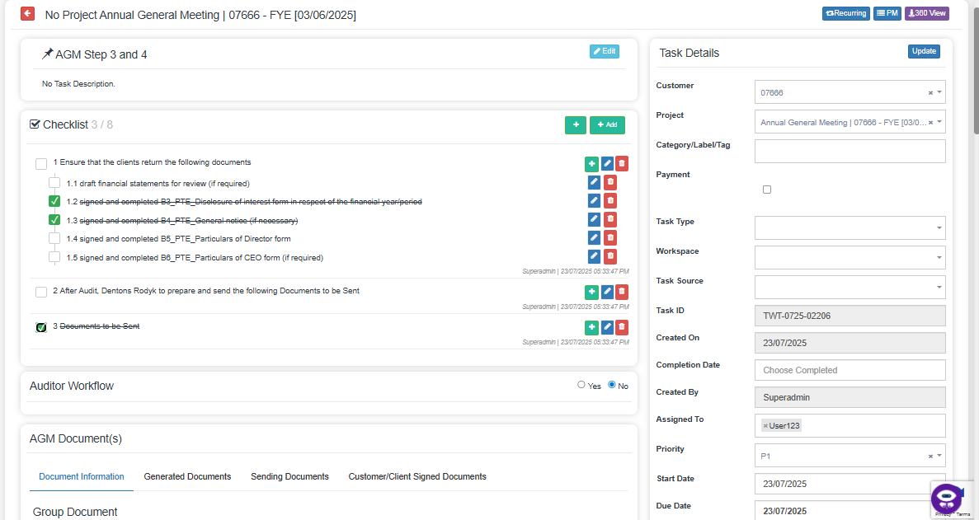
Auditor WorkFlow

System will show the Auditor WorkFlow by Yes or No option.
Yes shows Auditor worklows

View all Auditors
- Click Auditors -> View all Auditors by navigating to Auditor pages
There can check all the auditor related data’s

Appoint Auditors

- Click Appoint Auditors -> It navigating to Appoint Auditor page
- There can Add new auditor by filling the forms

Removal Auditors

- Click Remove or Change Auditors -> It navigating to Remove or Change Auditor page
- There can Remove or change auditor by filling the forms or can select in the list shown below

AGM Documents
- Document Information ->
- 1) If the company is not exempt from audit requirement:
- B11_PTE_Attendance note re. review of statutory records by auditors
- B10_PTE_Email re. review of statutory records by auditors
- 2) After Audit, Dentons Rodyk to prepare and send the following (if required):
- B12_PTE_Email enc. Form of representation letter as to minutes/resolution (for Director's signature)
- B13_PTE_Forms of representation letter as to minutes/resolution (by Director/ by our named Secretary)

- Generated Documents -> Can check all generated documents and can view, download or delete

Click on Generate @ Document Information Section to add templates into
Default Generated Documents Section
*Note that these templates are dummy templates.
Only the naming follows the given excel from Dentons

Generated Document @ Default Generated Documents Section can be previewed / deleted
Attach Custom Documents @ Add Custom Document Section
Click on + to attach more custom documents

Select Email Template (Pre-configured in Settings) to be sent out to Clients

Click on:
Submit & Email
Email Preview from the defaulted chosen template with be displayed along with contact person email.

Email content can be amended at this stage before email is sent out to contact person

Click on:
- Send & Submit

- Sending Documents -> Here can see all sending related data’s of the documents

Denton’s Client Receive Email in their Inbox

Click on:
Update Document Link
Denton’s Client Open URL

Official Download Documents Section:
Will display documents attached by Dentons:
- Generated Documents
- Custom Documents

Clients can upload the signed copies of the documents using the Upload section with the Upload Button

Your Uploaded Document Section:
Will display all the uploaded documents from client with Status: pending (just uploaded)
Note: Clients to provide :
- draft financial statements for review (if required)
- signed and completed B3_PTE_Disclosure of interest form in respect of the financial year/period
- signed and completed B4_PTE_General notice (if necessary)
- signed and completed B5_PTE_Particulars of Director form
- signed and completed B6_PTE_Particulars of CEO form (if required)

Your Uploaded Document Section:
Will display all the uploaded documents from client with Status: pending (just uploaded)

Click on:
Submit
- Customer/Client Signed Documents -> Can check all generated documents and can view, download or delete

Confirm Document
After Changing the status of the document was completed, Pending, etc.

Submit Confirm Document -> Change the due Date.
It’s automatically return to Home page.

Status Changed  After Return to Home page check the AGM steps 3 and 4 Status. | 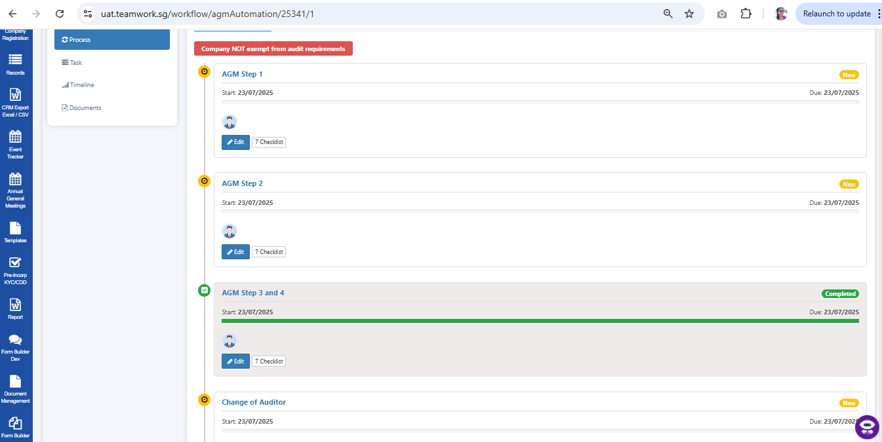
CHANGE OF AUDITORS  System will show the Change of auditors  Click on:  + 1. Edit | 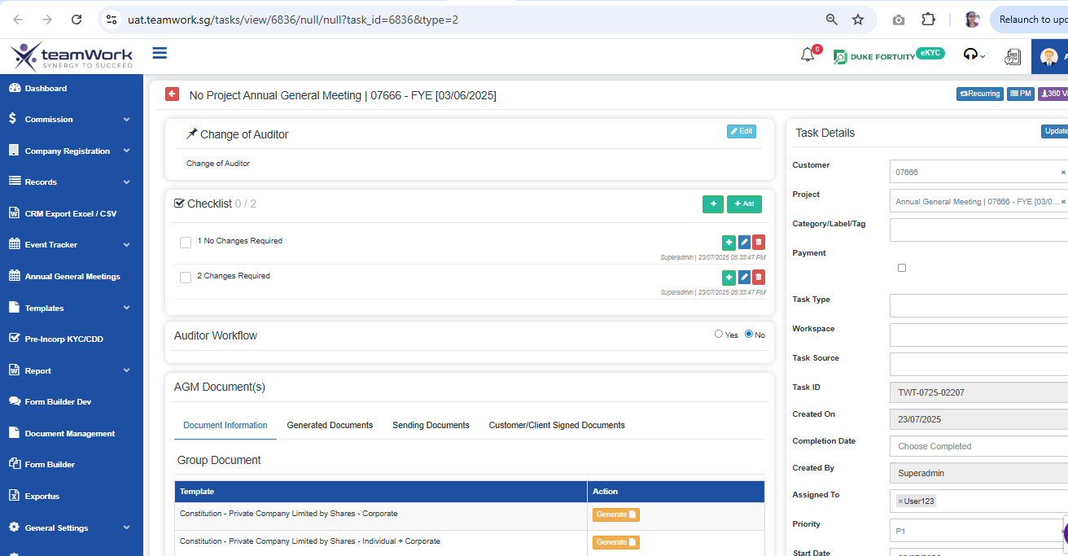
Checklist  Non-Exempt from Audit  System will show the AGM Checklist  - In Checklist , can edit , mark tick , untick , add and delete  - Auditor workflow-> Can View all auditors, appoint and change or remove auditor | 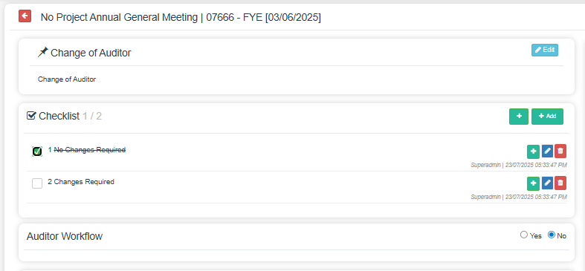
Auditor WorkFlow

System will show the Auditor WorkFlow by Yes or No option.
Yes shows Auditor worklows

View all Auditors
- Click Auditors -> View all Auditors by navigating to Auditor pages
There can check all the auditor related data’s

Appoint Auditors

- Click Appoint Auditors -> It navigating to Appoint Auditor page
- There can Add new auditor by filling the forms

Removal Auditors

- Click Remove or Change Auditors -> It navigating to Remove or Change Auditor page
- There can Remove or change auditor by filling the forms or can select in the list shown below

AGM Documents
- Document Information -> Can check Group Document and Template Document. Also can generate the document.

- Generated Documents -> Can check all generated documents and can view, download or delete

Click on Generate @ Document Information Section to add templates into
Default Generated Documents Section
*Note that these templates are dummy templates.
Only the naming follows the given excel from Dentons

Generated Document @ Default Generated Documents Section can be previewed / deleted
Attach Custom Documents @ Add Custom Document Section
Click on + to attach more custom documents

Select Email Template (Pre-configured in Settings) to be sent out to Clients

Click on:
Submit & Email
Email Preview from the defaulted chosen template with be displayed along with contact person email.

Email content can be amended at this stage before email is sent out to contact person

Click on:
- Send & Submit

- Sending Documents -> Here can see all sending related data’s of the documents

Denton’s Client Receive Email in their Inbox

Click on:
Update Document Link
Denton’s Client Open URL

Official Download Documents Section:
Will display documents attached by Dentons:
- Generated Documents
- Custom Documents

Clients can upload the signed copies of the documents using the Upload section with the Upload Button

Your Uploaded Document Section:
Will display all the uploaded documents from client with Status: pending (just uploaded)
Your Uploaded Document Section:
Will display all the uploaded documents from client with Status: pending (just uploaded)

Click on:
Submit
- Customer/Client Signed Documents -> Can check all generated documents and can view, download or delete

Note: Clients' Directors approve financial statements, signed:
- B19_PTE_Text of Directors resolution (private company)
- Directors' Statement

Confirm Document
After Changing the status of the document was completed, Pending, etc.

Submit Confirm Document -> Change the due Date.
It’s automatically return to Home page.

Status Changed  After Return to Home page check the AGM steps Status. | 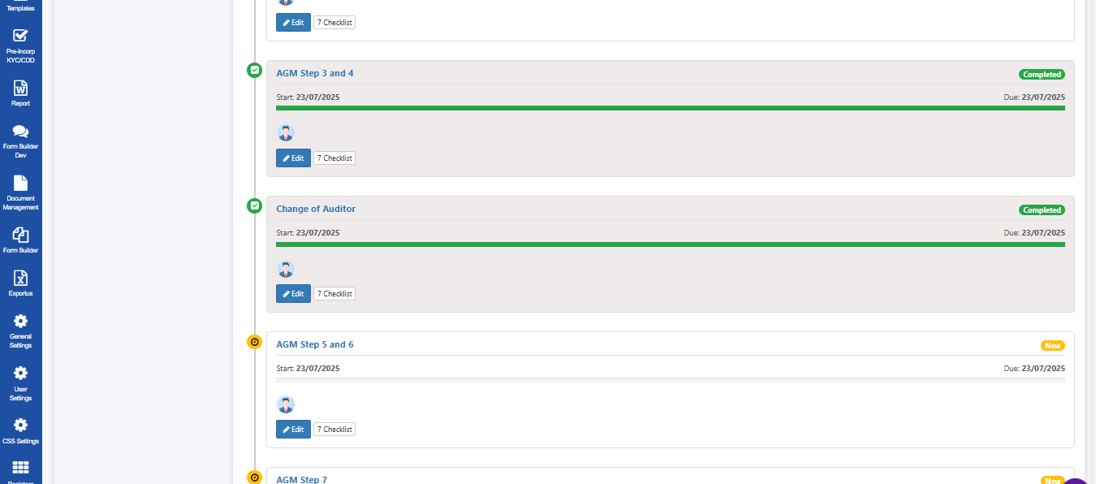
AGM Step 5 & 6  System will show the AGM Step 5 & 6  Click on:  + 1. Edit | 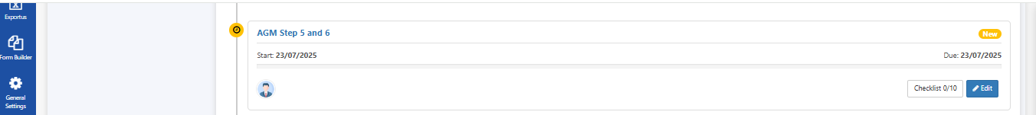
Checklist  Non-Exempt from Audit  System will show the AGM Checklist  - In Checklist , can edit , mark tick , untick , add and delete  - Auditor workflow-> Can View all auditors, appoint and change or remove auditor | 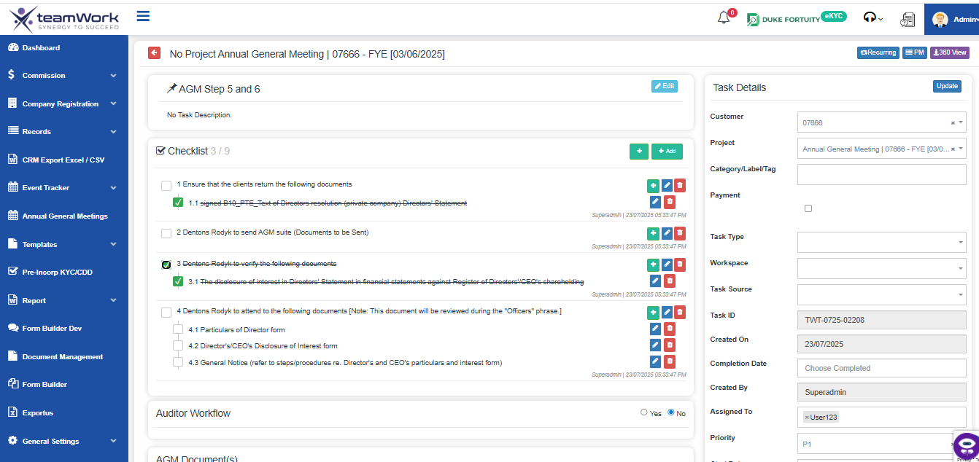
Auditor WorkFlow

System will show the Auditor WorkFlow by Yes or No option.
Yes shows Auditor worklows

View all Auditors
- Click Auditors -> View all Auditors by navigating to Auditor pages
There can check all the auditor related data’s

Appoint Auditors

- Click Appoint Auditors -> It navigating to Appoint Auditor page
- There can Add new auditor by filling the forms

Removal Auditors

- Click Remove or Change Auditors -> It navigating to Remove or Change Auditor page
- There can Remove or change auditor by filling the forms or can select in the list shown below

AGM Documents
- Document Information ->
- Can check Group Document and Template Document. Also can generate the document.

- Generated Documents -> Can check all generated documents and can view, download or delete

Click on Generate @ Document Information Section to add templates into
Default Generated Documents Section
*Note that these templates are dummy templates.
Only the naming follows the given excel from Dentons

Generated Document @ Default Generated Documents Section can be previewed / deleted
Attach Custom Documents @ Add Custom Document Section
Click on + to attach more custom documents

Select Email Template (Pre-configured in Settings) to be sent out to Clients

Click on:
Submit & Email
Email Preview from the defaulted chosen template with be displayed along with contact person email.

Email content can be amended at this stage before email is sent out to contact person

Click on:
- Send & Submit

- Sending Documents -> Here can see all sending related data’s of the documents

Denton’s Client Receive Email in their Inbox

Click on:
Update Document Link
Denton’s Client Open URL

Official Download Documents Section:
Will display documents attached by Dentons:
- Generated Documents
- Custom Documents

Clients can upload the signed copies of the documents using the Upload section with the Upload Button

Your Uploaded Document Section:
Will display all the uploaded documents from client with Status: pending (just uploaded)
Note Clients' Directors approve financial statements, signed:
- B19_PTE_Text of Directors resolution (private company)
- Directors' Statement

Your Uploaded Document Section:
Will display all the uploaded documents from client with Status: pending (just uploaded)

Click on:
Submit
- Customer/Client Signed Documents -> Can check all generated documents and can view, download or delete

Confirm Document
After Changing the status of the document was completed, Pending, etc.

Submit Confirm Document -> Change the due Date.
It’s automatically return to Home page.

Status Changed  After Return to Home page check the AGM steps 5 and 6 Status. | 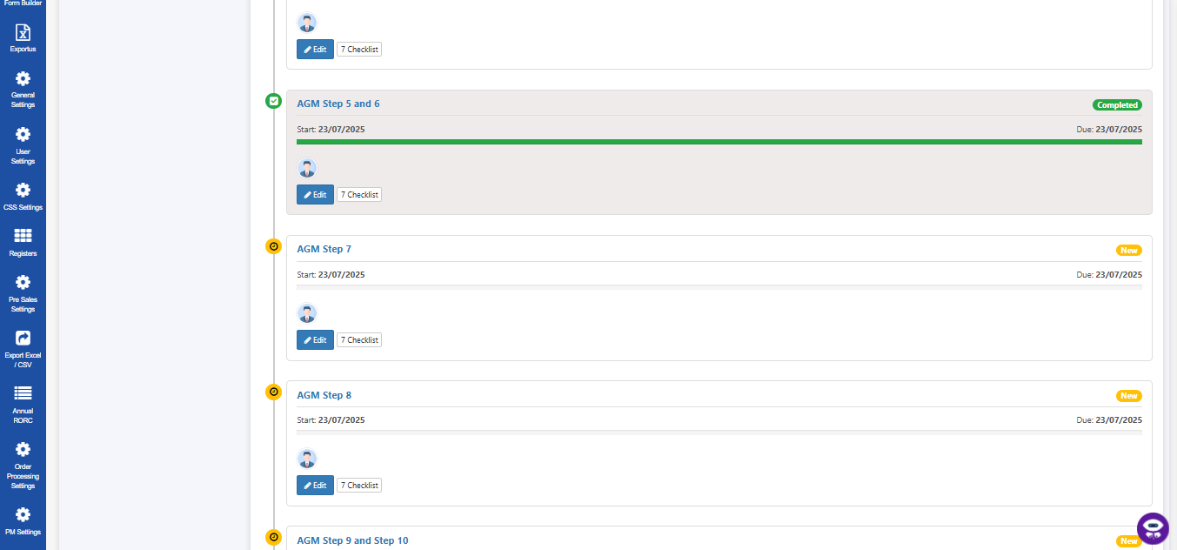
AGM Step 8  System will show the AGM Step 8  Click on:  + 1. Edit | 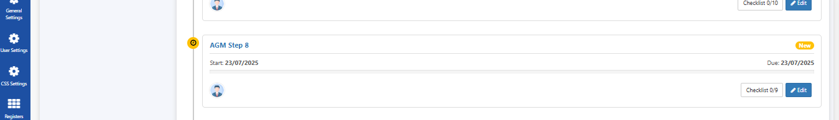
Checklist  System will show the AGM Checklist  - In Checklist , can edit , mark tick , untick , add and delete  - Auditor workflow-> Can View all auditors, appoint and change or remove auditor  - Note: Auditors sign report to financial statements (skip this step if company is exempt from audit requirements). | 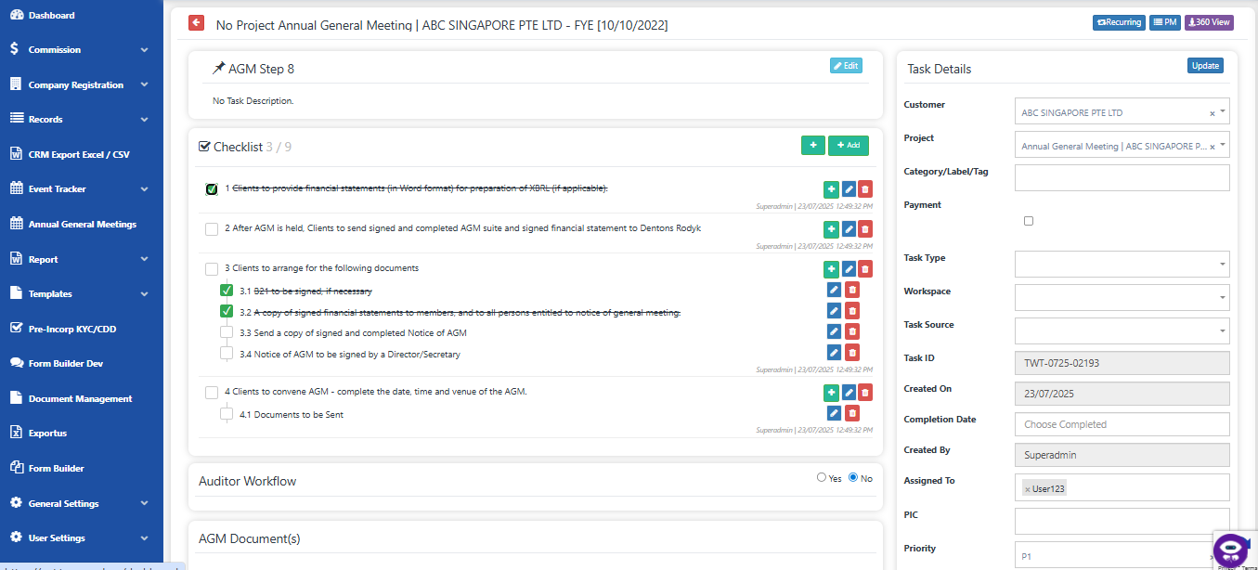
Auditor WorkFlow

System will show the Auditor WorkFlow by Yes or No option.
Yes shows Auditor worklows

Step 7 : Removal and Appointment of Auditors (if applicable)
- Notify ACRA of Auditor Removal
Dentons Rodyk will inform ACRA in writing once the Special Resolution to remove the existing auditors is passed.
- Submit Auditor Change Notification to ACRA
Dentons Rodyk will notify ACRA of both the removal and new nomination of auditors within 14 days from the date of the EGM.
- File Supporting Documents (if wholly-owned subsidiary)
If the company is wholly-owned, Dentons Rodyk will also file a copy of the Minute by the Representative of the Holding Company with ACRA.

View all Auditors
- Click Auditors -> View all Auditors by navigating to Auditor pages
There can check all the auditor related data’s

Appoint Auditors

- Click Appoint Auditors -> It navigating to Appoint Auditor page
- There can Add new auditor by filling the forms

Removal Auditors

- Click Remove or Change Auditors -> It navigating to Remove or Change Auditor page
- There can Remove or change auditor by filling the forms or can select in the list shown below

AGM Documents
- Document Information -> Can check Group Document and Template Document. Also can generate the document.

- Generated Documents -> Can check all generated documents and can view, download or delete

Click on Generate @ Document Information Section to add templates into
Default Generated Documents Section
*Note that these templates are dummy templates.
Only the naming follows the given excel from Dentons

Generated Document @ Default Generated Documents Section can be previewed / deleted
Attach Custom Documents @ Add Custom Document Section
Click on + to attach more custom documents

Select Email Template (Pre-configured in Settings) to be sent out to Clients

Click on:
Submit & Email
Email Preview from the defaulted chosen template with be displayed along with contact person email.

Email content can be amended at this stage before email is sent out to contact person

Click on:
- Send & Submit

- Sending Documents -> Here can see all sending related data’s of the documents

Denton’s Client Receive Email in their Inbox

Click on:
Update Document Link
Denton’s Client Open URL

Official Download Documents Section:
Will display documents attached by Dentons:
- Generated Documents
- Custom Documents

Clients can upload the signed copies of the documents using the Upload section with the Upload Button

Your Uploaded Document Section:
Will display all the uploaded documents from client with Status: pending (just uploaded)
Note:
Your Uploaded Document Section:
Will display all the uploaded documents from client with Status: pending (just uploaded)

Click on:
Submit
- Customer/Client Signed Documents -> Can check all generated documents and can view, download or delete

Confirm Document  After Changing the status of the document was completed, Pending, etc.  Submit Confirm Document -> Change the due Date.  It’s automatically return to Home page. | 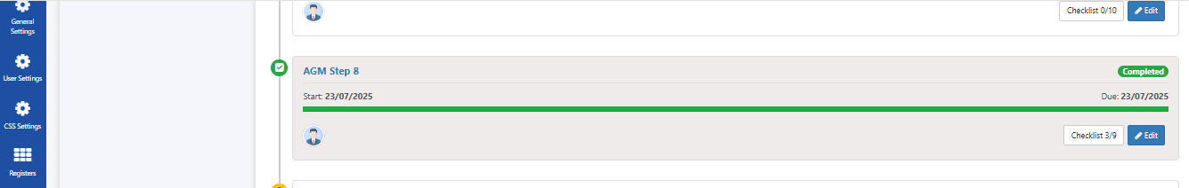
AGM Step 9 & 10  System will show the AGM Step 9 & 10  Click on:  + 1. Edit | 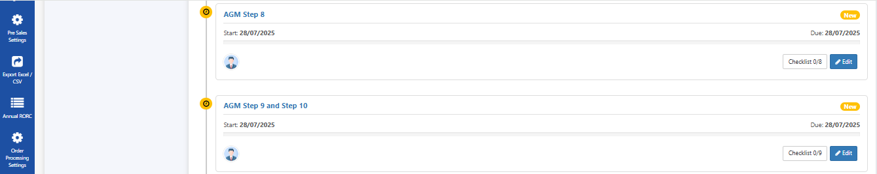
Checklist  Non-Exempt from Audit  System will show the AGM Checklist  - In Checklist , can edit , mark tick , untick , add and delete  - Auditor workflow-> Can View all auditors, appoint and change or remove auditor | 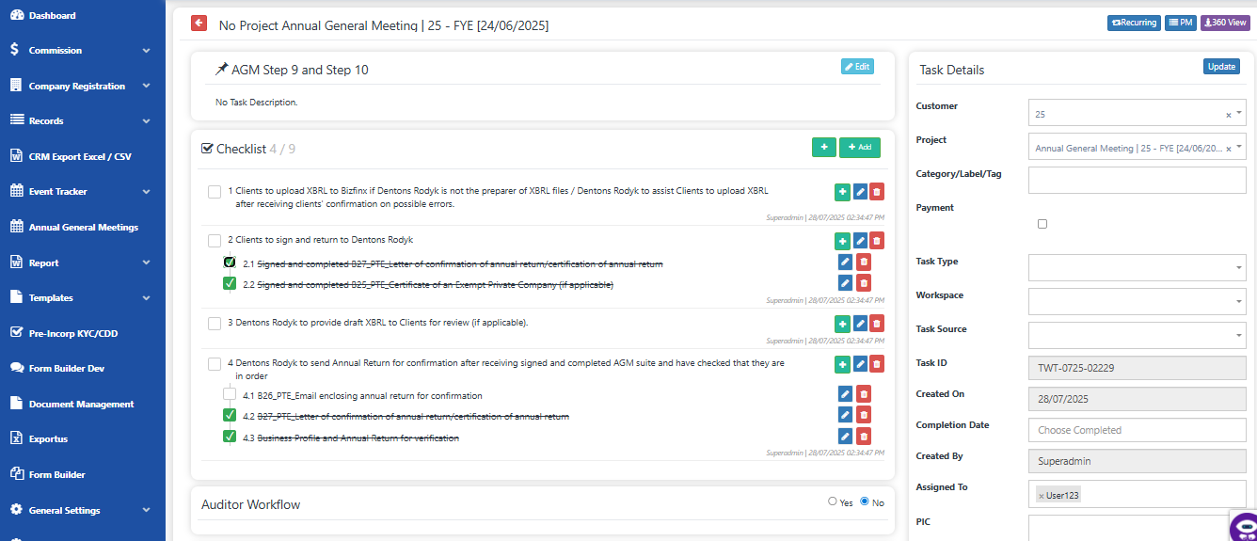
Auditor WorkFlow

System will show the Auditor WorkFlow by Yes or No option.
Yes shows Auditor worklows

View all Auditors
- Click Auditors -> View all Auditors by navigating to Auditor pages
There can check all the auditor related data’s

Appoint Auditors

- Click Appoint Auditors -> It navigating to Appoint Auditor page
- There can Add new auditor by filling the forms

Removal Auditors

- Click Remove or Change Auditors -> It navigating to Remove or Change Auditor page
- There can Remove or change auditor by filling the forms or can select in the list shown below

AGM Documents
- Document Information -> Can check Group Document and Template Document. Also can generate the document.

- Generated Documents -> Can check all generated documents and can view, download or delete

Click on Generate @ Document Information Section to add templates into
Default Generated Documents Section
*Note that these templates are dummy templates.
Only the naming follows the given excel from Dentons

Generated Document @ Default Generated Documents Section can be previewed / deleted
Attach Custom Documents @ Add Custom Document Section
Click on + to attach more custom documents

Select Email Template (Pre-configured in Settings) to be sent out to Clients

Click on:
Submit & Email
Email Preview from the defaulted chosen template with be displayed along with contact person email.

Email content can be amended at this stage before email is sent out to contact person

Click on:
- Send & Submit

- Sending Documents -> Here can see all sending related data’s of the documents

Denton’s Client Receive Email in their Inbox

Click on:
Update Document Link
Denton’s Client Open URL

Official Download Documents Section:
Will display documents attached by Dentons:
- Generated Documents
- Custom Documents

Clients can upload the signed copies of the documents using the Upload section with the Upload Button

Your Uploaded Document Section:
Will display all the uploaded documents from client with Status: pending (just uploaded)
Note : # confirmation of Annual Return is valid for 14 days (not more than before date of filing of Annual Return)

Your Uploaded Document Section:
Will display all the uploaded documents from client with Status: pending (just uploaded)

Click on:
Submit
- Customer/Client Signed Documents -> Can check all generated documents and can view, download or delete

Confirm Document
After Changing the status of the document was completed, Pending, etc.

Submit Confirm Document -> Change the due Date.
It’s automatically return to Home page.

Status Changed  After Return to Home page check the AGM steps Status. | 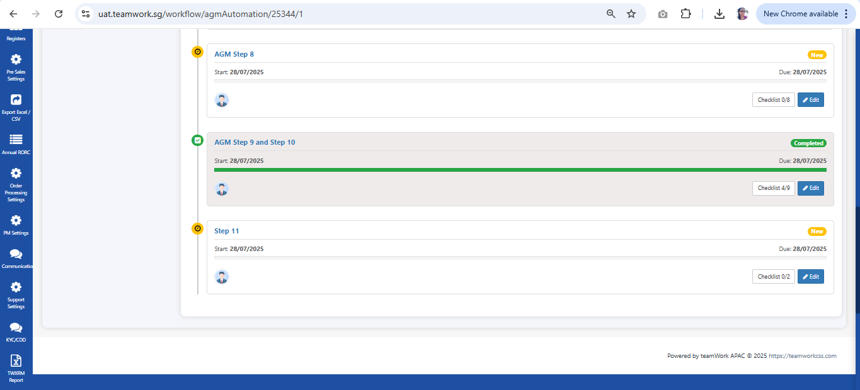
AGM Step 11  System will show the AGM Step 11  Click on:  + 1. Edit | 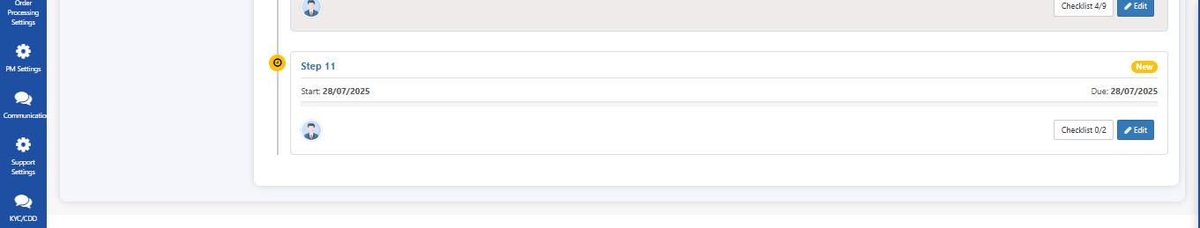
Checklist  Non-Exempt from Audit  System will show the AGM Checklist  - In Checklist , can edit , mark tick , untick , add and delete  - Auditor workflow-> Can View all auditors, appoint and change or remove auditor | 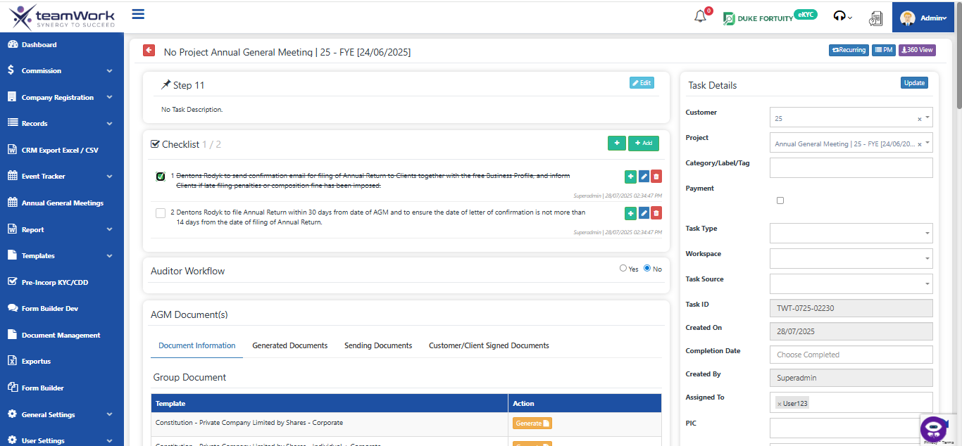
Auditor WorkFlow

System will show the Auditor WorkFlow by Yes or No option.
Yes shows Auditor worklows

View all Auditors
- Click Auditors -> View all Auditors by navigating to Auditor pages
There can check all the auditor related data’s

Appoint Auditors

- Click Appoint Auditors -> It navigating to Appoint Auditor page
- There can Add new auditor by filling the forms

Removal Auditors

- Click Remove or Change Auditors -> It navigating to Remove or Change Auditor page
- There can Remove or change auditor by filling the forms or can select in the list shown below

AGM Documents
- Document Information -> Can check Group Document and Template Document. Also can generate the document.

- Generated Documents -> Can check all generated documents and can view, download or delete

Click on Generate @ Document Information Section to add templates into
Default Generated Documents Section
*Note that these templates are dummy templates.
Only the naming follows the given excel from Dentons

Generated Document @ Default Generated Documents Section can be previewed / deleted
Attach Custom Documents @ Add Custom Document Section
Click on + to attach more custom documents

Select Email Template (Pre-configured in Settings) to be sent out to Clients

Click on:
Submit & Email
Email Preview from the defaulted chosen template with be displayed along with contact person email.

Email content can be amended at this stage before email is sent out to contact person

Click on:
- Send & Submit

- Sending Documents -> Here can see all sending related data’s of the documents

Denton’s Client Receive Email in their Inbox

Click on:
Update Document Link
Denton’s Client Open URL

Official Download Documents Section:
Will display documents attached by Dentons:
- Generated Documents
- Custom Documents

Clients can upload the signed copies of the documents using the Upload section with the Upload Button

Your Uploaded Document Section:
Will display all the uploaded documents from client with Status: pending (just uploaded)

Your Uploaded Document Section:
Will display all the uploaded documents from client with Status: pending (just uploaded)

Click on:
Submit
- Customer/Client Signed Documents -> Can check all generated documents and can view, download or delete

Confirm Document
After Changing the status of the document was completed, Pending, etc.

Submit Confirm Document -> Change the due Date.
It’s automatically return to Home page.

Status Changed  After Return to Home page check the AGM steps Status. | 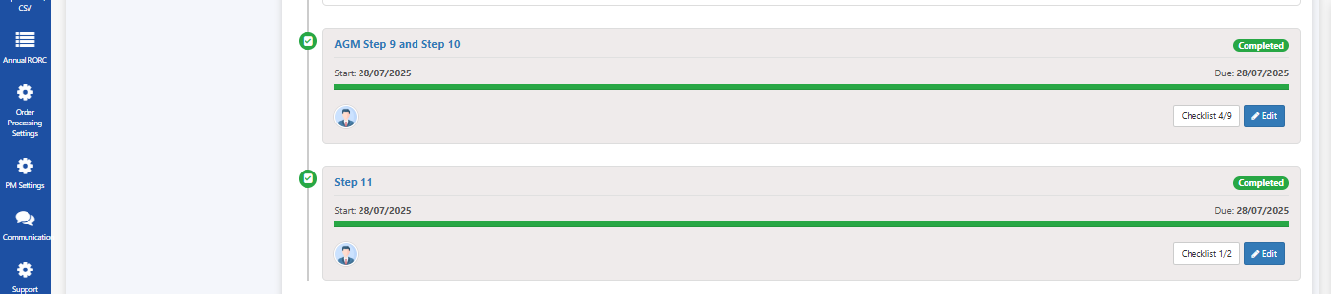
Task  - The system categorizes tasks as "Allocated" or "Unallocated" via dedicated tabs.  - Click "Edit" for the specific task: Find the row of the task you want to update and click the blue "Edit" button in the "Action" column on the far right.  - Modify desired fields: In the editing interface that appears, update details like "Progress," "Status," "Due Date," or any other relevant task information.  - Save changes: Confirm your updates by clicking the "Save" or "Update" button within the editing interface. | 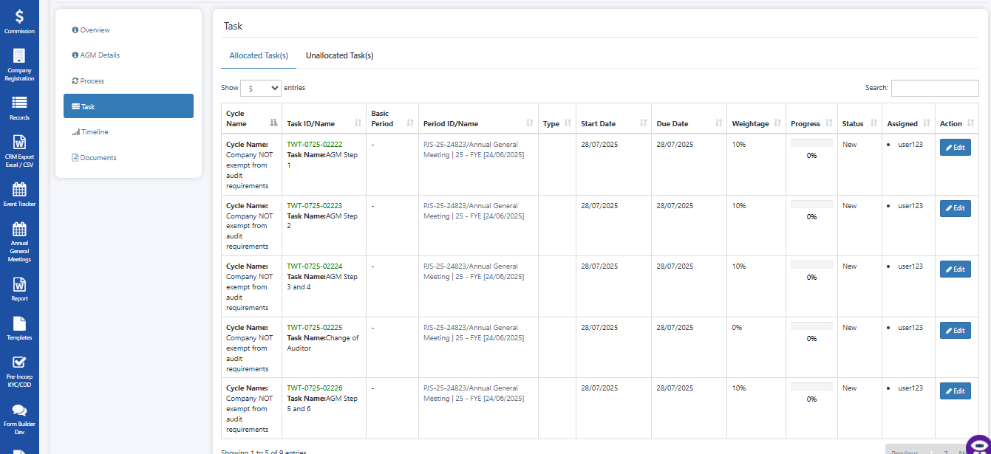
Timeline  - Overall Progress: Understand the progress bar and percentage.  - Time Scales: Use Quarter, Day, Half Day, Week, Month views.  - Timeline Display: Interpret tasks/milestones on the chronological chart.  - Navigation: Understand date range and how to move through time. | 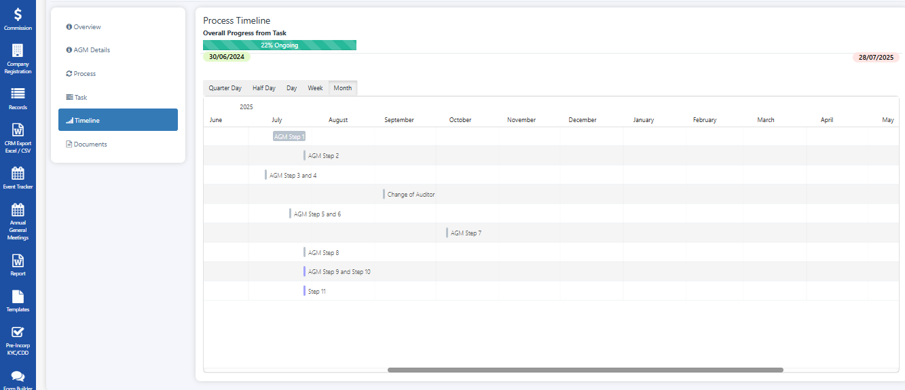
Documents  - Uploading documents using the "Upload Document" button.  - Managing client-signed documents and other updated materials by uploading them to centralize information.  - Leveraging potential sharing features to distribute documents to relevant parties. | 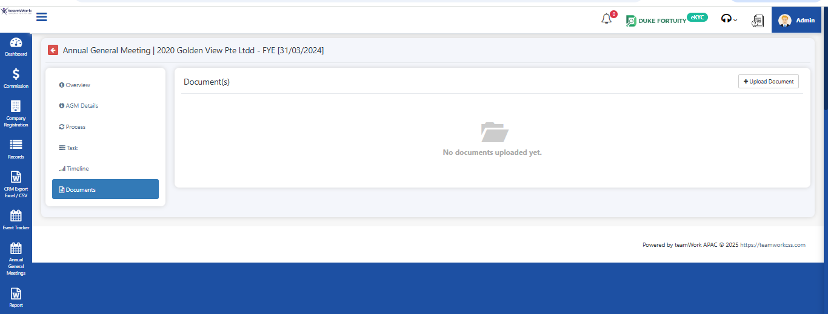  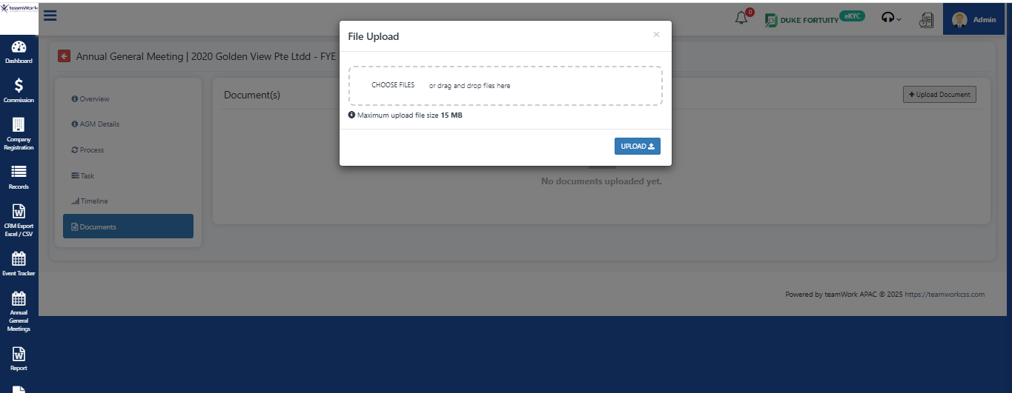
AGM Completion  AGM Details -> Edit AGM -> Select and fill the Filling/Completed Date -> Save.  Then AGM was Completed Successfully. | 